Student Centred – Project Work – Problem Solving

Brainstorming – Mind mapping

An Experiment – an Experience – a Practical Experience

By
Wulf-Dieter Krueger

Language Centre

Rajabhat University, Udonthani

Contents
I am not very good at theory. 2
Student centred 2
Project Work – Problem Solving 2
Brainstorming 1 - Collecting ideas 3
Brainstorming 2 - Sorting out ideas 3
Mind-mapping 4
Mind-mapping – class task 4
Mind-mapping – groups’ tasks 4
Students’ tasks 5
Teacher's tasks 5
Technical equipment 5
‘Paradise’ equipment 5
Reality/minimal equipment 6
Hurdles 6
Overcoming traditions 6
Teacher’s patience 6
Students’ patience 7
Language skills 7
Outlook 8
Motivation and Success 8
Success? 9
Two Individual papers from each map 15
1) A fourth year student working of fatal traffic accidents 15
Malaysia 15
2) A second year student working on public health problems in Thailand 18
Underpaid health staff 18

I am not very good at theory.
And, I am quite outspoken using direct language instead of verbose jargon. I am rather a doer, learning by experience of how things work out to do some fine tuning here and there, if things do not turn out the way I anticipated.

I have heard about student centred, project work, problem solving, brainstorming, mind mapping and communicative approach at IATEFL / TESOL conferences and/or learnt about them during my 20 years of work as a freelancer in corporate training in Germany - at language schools in Germany and in Thailand, however, only at those in industrial/corporate training (intensive/extensive/total immersion).
I did this kind of language training in industry/corporate training, particularly in intensive -/total immersion courses on managerial level, when, just by watching managers handling problems within a simulation they were doing, I learnt about brainstorming and flow-charting.
Yes – indeed – there are situations when teachers can learn from their students, and, when you listen to your students you can learn a lot.
Mind mapping in the 70s was called flow-charting (that found its way into language training through ‘Tashi Airport’) and it was in the 90s that an industrial trainer let me see his mind mapping map he used to do his training.

So, when I saw some mind mapping software the other day (about 5 semesters ago) I just thought, why not give it a try with my students at the Language Centre, Udonthani Rajabhat University.

Student centred
In communicative approach teaching/learning the focus shifts from the teacher away to the students. It is not anymore the teacher controlling everything (and the teacher being controlled by a book) and the students speak after the teacher and the book - when learning by rote is the in-thing, resulting in the students talking about something they actually do not understand, because it is beyond their experience or interest.
Of course there are moments when rote learning is important, namely during pattern practice drills – yes I do use this ugly word that is called sometimes different theses days.
Student centred teaching/learning engages the student, however, it does not mean that the teacher comes to class, sets the students a task, arranges the groups and goes away to have a cup of tea. The teacher’s role here is to help and to monitor and take notes for remedial exercises as required.

The issue, of course, is, how to render teaching/learning student centred?
Based on my personal experience, simulations and project-/problem solving work have just the ideal answers.

Project Work – Problem Solving
A well selected project, or ideally a project chosen by the students themselves, thus a tangible project for the students, to be solved using English or any other language is the students’ not the teacher’s. Such a project is meaningful to the students and any outside subject/project related input becomes meaningful and tangible even though, initially, it might be very difficult to understand language wise.
This in itself is highly motivating and ideally results in the students forgetting they are speaking English whilst doing their project.
Students begin using English as a tool for communication and interact student-student-teacher.
They do not experience English being an academic exercise any more.
They do not suffer anymore from the top-down teacher centred situation and they need to ask for help when they are stuck for factual knowledge, perhaps.
They, by nature of project work, experience the teacher in a different way – as a learning-teaching partner as the teacher helps them out.
All learn to live with the fact that nobody knows everything.
They learn how to find information – in the library, on the internet, from someone, who might know.
They learn to ask questions again and that not knowing is not shameful.
All this, just because there is a project or a problem to solve - and it is new – and it is not in a book – it is theirs!

Brainstorming 1 - Collecting ideas
Brainstorming has been well established in business, management and management training for years.
It is a problem solving tool.
It is very communicative, since all students can participate in it and initially there is no negative feedback.
Any idea that might contribute to help solving the problem (even the silliest at first sight) is acceptable and will be put onto the board/overhead/screen in the correct spelling since the teacher does the writing/typing.
Typos might happen and students are very happy to be able to correct the teacher and learn that the teacher is not always right.
There might, however, be a cultural hurdle in Asia to make this happen. Yet even this must be learnt, and brainstorming does treat everyone the same in a group as the ideas count and not seniority.
Any first idea seen on the board triggers another idea, the next, etc. as students hear and see what is going on.
This has a motivating effect, as students will try harder when there is more than one idea on the board.
And – this is the students', as the teacher does not interfere – he/she only monitors language not ideas (at times it might be necessary, though, for the teacher to point into the right direction, i.e. when the students might miss out on something that is in the project).

Brainstorming 2 - Sorting out ideas
The next stage in brainstorming is to weed out the silly ideas to retain the viable ideas for solving the task / problem.
Initially, however, the students expect the teacher to say yes or no, anyway, this is a teacher’s traditional role. The teacher must not do this, even if it might take too long according to the teacher’s planning.
We are talking about project work and student centred – so the students do this bit on their own. The teacher monitors language as before and does not intrusively interfere with corrections.
The teacher might have to introduce the language patterns as to stating ones idea and disagreeing, after which he/she only sees to it that the patterns are used properly in a non-interfering way.
Students have to do a lot of listening and speaking here, as they cannot just take a majority vote but must state their ideas, reason their ideas and convince each other.
Once an idea has been agreed on as being a viable idea the teacher will mark it as such. Ideas that the students agree on not being viable will be erased.

Mind-mapping
Mind-mapping (or flow charting as it was called some years ago) visualises thought.
According to Mayer (2002) individuals can process additional information, if it is presented additionally in two forms (auditory and pictorially and information can be represented in the brain in either the verbal or visual code. Churchill (2005, p 341-342) claims ‘… different representations are more efficient when dealing with different tasks of a … reasoning task’. It can thus be concluded that with mind mapping allows students to process the information from discussion in both the auditory mode and a visual mode and thus accommodates two different learning styles.
The Cognitive Load Theory (Sweller (2003) and Eggen & Kauchak (2004) and Baddeley (1998)) implies that there is a limited space of working memory to process information so students my lose information being discussed because they have to remember of what has been said. Mind mapping visualises information reducing this ‘memory overflow’ (as we would put it in computing terms) freeing working memory for reasoning. This frees the students’ potential to develop thinking and reasoning skills applied to problem solving helping them to alter their perceptions based on other students’ points of view which is, in the end, learning.
Mind-mapping is used as a tool to solve problems and to visualise a path to the solution and not fit a solution into a mind-map.
Students/participants can see on the map what has been thought before and build on that, which corresponds with the natural way of all learning processes whereby each learning step bases on the level arrived at through previous learning stages.
The task at hand is to organise the valid ideas into groups and then to decide on the ranking within this group. It starts with the group names to be determined.
The students decide on the group names looking at their valid ideas. Again the teacher has no say, as he/she only monitors language.

Mind-mapping – class task
The class as a whole decides on the names of the groups and then on the ideas that belong into that group.

Mind-mapping – groups’ tasks
The group names decided on by the whole class in the work-phase before now become groups of students. The students within the groups now organises their ideas as to priority, i.e. they rank the ideas as to importance – what is the first thing to do, the next and so on.
In this way the students of the individual groups work out a work schedule for the group. They themselves will assign each student a task (subtopic/idea) to work on. They themselves will decide how and for what they might have to co-operate with the other groups.
All this will be the groups’ first presentations (using PowerPoint) outlining to the other groups what they are going to do.

Students’ tasks
In co-ordination with other students in the group students now collect their material for their individual papers. The teacher’s help is required here as well, for once the students have decided on a subject the teacher begins searching the material required on the internet to have it ready when needed / for students, who do not have internet access. On the other hand the students should be encouraged to retrieve data/information from the internet inaccessible for the teacher who might be a foreign teacher not being able to read Thai.
Once the students have collected their material they start writing their papers in preparation for their individual presentations.

Teacher's tasks
The teacher does not interfere, only provides guidance and help if students get stuck.
The teacher monitors language and provides error correction in a non-interfering manner like making correct versions visible to the students on the board/screen. For errors that cannot be weeded out this way, the teacher provides remedial exercises (e.g. pattern drills for certain structures or language – and very important vocabulary - needed by the students for their interaction).
The teacher sees to it that the whole process of brainstorming and mind-mapping remains transparent for the students.
The teacher assists students to find material on the internet.
The teacher assists students to prepare their presentations and their papers (this could entail instructions on how to use PowerPoint for generating presentations, and Word (including the use of the spell- and grammar checker) and of course instructions on how to structure of a presentation/paper and what to observe producing these.
The teacher handles the technical aspects of the procedure.
In other words – the teacher is responsible for the scaffolding.

Technical equipment

‘Paradise’ equipment
Mind-mapping software (e.g. Mindjet MindManager Pro 6). I decided to pick this software, because it looks most analogue.
Laptop computer/computer, projector and printer are available in the classroom to provide students:
a) With instant feedback of their thinking processes – to be printed from the mind-mapping software.
b) With instant unobtrusive visible error correction – to be printed from a Word document.
c) With handouts of a) and b) for revision as homework directly after each session.

Having the computer available in the classroom allows you to instantly flip between application pages by just hitting Alt-Tab, whenever you need to show students a correct version of what they have just said.
I prefer to give students correct versions only, since I once learnt that students should never see anything that is wrong contrasted with a corrected version, because it leads to intra-lingual interferences, meaning there is the risk of the students mixing up the incorrect with the correct version in the same way as the translation method I have seen being applied in Thailand brings about inter-lingual interference (Krashen on error correction in ‘The Natural Approach’).

Reality/minimal equipment
Mind-mapping software (e.g. Mindjet MindManager Pro 6).
Laptop computer/computer, projector and printer are not available in the classroom, but there is an overhead projector. This requires blank OHP transparencies for each session and OHP markers in different colours.

This means that at the outset there is just a blank OHP transparency and the name of the project will be manually entered once the students have decided on the master topic/project/problem. Each idea produced will be manually entered producing a hardcopy of what goes on in the classroom. Unobtrusive error corrections will be written onto the board/second transparency.
After each session the teacher processes the corresponding data, prints a new OHP transparency of the mind-map and printouts of the mind-map, and handouts of error corrections for students’ revision work to be handed out the next session.
My first test-run was done this way and it was amazing to watch students immediately using markers to colour their printed maps according to the map on the OHP and checking the other printouts.
After they had done this the process continued.

Hurdles

Overcoming traditions
The students we get here at the Language Centre, Udonthani Rajabhat University are used to teacher centred learning – a teaching situation where the teacher spoon-feeds the students with knowledge from books that may be very old. There is hardly any student-student interaction. The teacher – student interaction prevails, i.e. the teacher asks and the student replies. Most of the time students do not answer, because they are afraid of making a mistake – so the teacher provides the answer as well.
Students on the other hand dare not ask questions for whatever reason - teachers might lose face.

In one of the papers produced a student describes the situation as follows:
“Another cause for people having no knowledge is teachers, who do not do their duty or teachers who only want to teach to end the topic.
When students do not understand we do not ask. There is no talking or communication about questions or problems.
The objectives are not OK and the ways of teaching are not OK causing the problem of the standard of education becoming lower.”

This method forces students and teachers to re-learn their roles. Students have to learn to become inquisitive again and teachers have to learn listening to their students – and most importantly - teachers will have to learn to accept that they are not the sole source of students’ knowledge.
Both, teachers and students will have to come to grips with the notion that you learn a language for using it as a means of communication and not as a means of passing a test of unrealistic grammar exercises by an irrelevant multiple choice test, where everything is pre-produced, or memory tested by reproducing all that the teacher has said.

Teacher’s patience
A teacher embedded in the tradition of a teacher centred learning/teaching situation where everything is under his/her control, including the timing even down to the minute, will have to learn to give students time for learning/understanding the new situation of the teacher not deciding what is right or wrong. The teacher will have to be patient with him-/herself to adapt to the situation that this way of work is real and communicative that may take unexpected directions not anticipated.
The teacher will have to be patient to re-learn that learning is trial and error and allow the students to come to grips with the situation that trying is more important than giving ‘correct’ answers instantly – one of the main reasons why Thai students are shy/afraid to speak English.
Patience is required to learn that students’ mistakes are indeed good for learning, especially when students self correct instead of being interrupted and corrected by the teacher all the time, whose corrections go into the student’s one ear and leaving it by the other, as proven by the fact that the majority of students at the Language Centre, Udonthani Rajabhat University do not master basic English grammar although they had been exposed to at least six or even 12 years of learning grammar when they registered at this university.

Students’ patience

A student embedded in the tradition of a teacher centred learning/teaching situation where everything is beyond his/her control and controlled by an ‘omnipotent’ teacher will have to learn to become to be patient with a teacher embedded in tradition trying to learn new skills. This of course is true the other way round as well, i.e. the student will have to re-learn the natural curiosity of ‘never stop asking’ s/he used to have before s/he entered the school system, when all of a sudden hair-cut and dress-code became more important than learning by asking questions.
Students will have to be patient to understand that there are no quick fixes and that bypassing problems by not asking questions when they must be asked are counter-productive.
Students must also learn to be patient with themselves, meaning that they must understand that learning a language is not instant and requires persistent work focussing more on words and meanings than posh grammar rules.
They are learning and this takes time. Decision making takes time. Thinking takes time. Learning and understanding the meaning of words and their proper usage takes time. Learning to apply grammar rules takes time.

Language skills

The students we get at the Language Centre, Udonthani Rajabhat University unfortunately do have very basic language skills due to a principle that seems to be that ‘a good teacher does not fail students’. In other words, the students we get have never had to bear the consequence of their idleness perhaps being caused by rote learning the same grammar items over and over again and/in addition to not related to reality from maybe being taught from an antique grammar exercise book.
Most of our students have to come to grips with the totally new situation that they are not taught in Thai about English - this English only situation is new to them.
Thus the students need a brush-up in basic listening and speaking skills plus vocabulary and grammar.
At the Language Centre, Udonthani Rajabhat University we are fortunate to have the computer-based (CALL) multi-media Ellis system.
Due to the fact that our students have been trained to pass tests, some aspects/features of the system had to be modified to stop students taking short-cuts. Over time our colleague, Peter Covey, has fine-tuned the system and put in stops once students found a new way of ‘hacking’ the system.
Students who do Ellis Basics and Intro properly will succeed in participating actively in this regular classroom work and the more actively they transfer English learnt in Ellis the more they learn to speak English.
This motivates hesitant students to take more risks and participate improving their flow of spoken language – on a simple language level.
This is what this work is after!

Outlook
Unfortunately the teacher who uses this approach does not necessarily harvest what s/he sows as to the written end product, particularly in the setting at the Language Centre, Udonthani Rajabhat University, where we have about 45 hours to tackle issues that have been neglected for quite some time, due to which the students have been frustrated for quite a while in such a way that they even hate English and do not want to hear about any more.
It will be the next foreign teacher continuing a similar English only approach who will enjoy the results of this work.
You yourself, if you get the feedback from the colleague after you, will be positively surprised by what written work (that you perhaps were not very happy with) your students will be able to achieve in the course of the next 45 hours.

The situation we are currently in at UDRU’s Language Centre, i.e. there are no entry tests to the
university any more, means that since one semester ago we have been getting students whose English language skills have become even more rudimentary.
This has resulted in more emphasis on Ellis and basic acquisition skills like why and how to use a vocabulary notebook.
Last, but not least, this approach requires co-operation between students and teacher and most importantly listening to one another – a skill our students urgently need.

Motivation and Success
However putting hurdles aside, brainstorming and mind mapping visualise thought. Students see the results of their efforts and thus English becomes tangible, comprehensible and meaningful to them. They gradually learn to bring their ideas across and they learn that they may indeed communicate successfully – not necessarily in Oxford English, but in comprehensible simple non-native English – being understood by one another including, in my case, by the foreign teacher and of course the other way round – they begin to understand one another and the foreign teacher better.
Success spells away frustration due to English, not over night, but gradually.
Success begins to challenge students.
Success motivates the students.
Motivated students will want more, will ask for more – will ask questions.
Motivated students will begin to learn from understanding instead of just repeating.
Motivated students will eventually understand that English is tangible and may be effectively used in communication.
Success and motivation or success through motivation renders English meaningful to the students and fosters communication.
Being able to communicate in English is what our students need for their future careers – just open the Bangkok Post’s classified section and you will find that our students need English for communication.

The following 11 pages demonstrate what students are able to achieve by learning by means of project work, brainstorming and mind-mapping.

Success?

Look for yourself! Map – development and one end-product

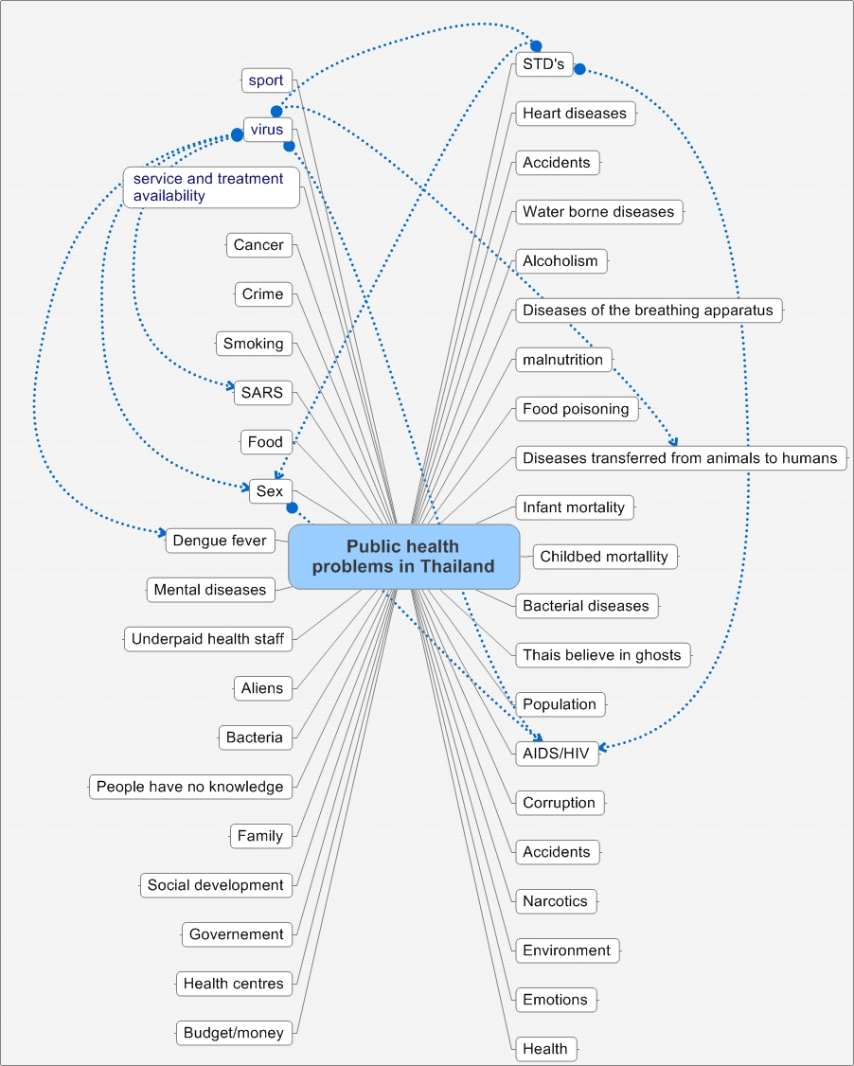
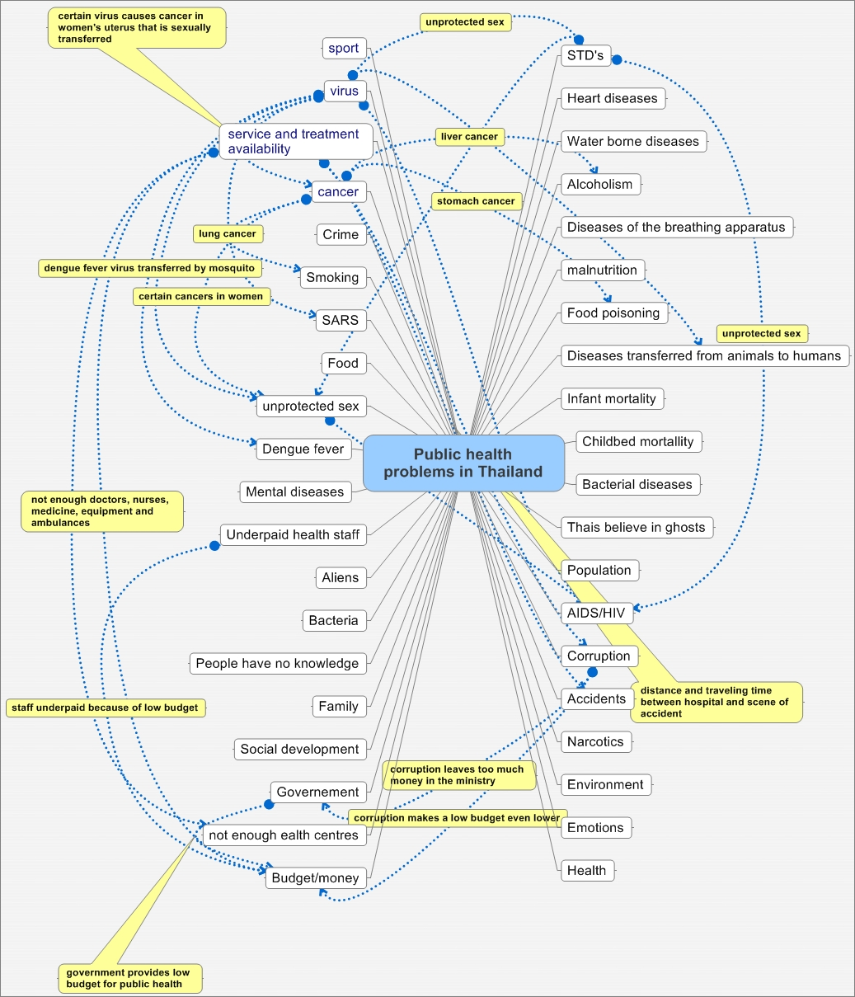
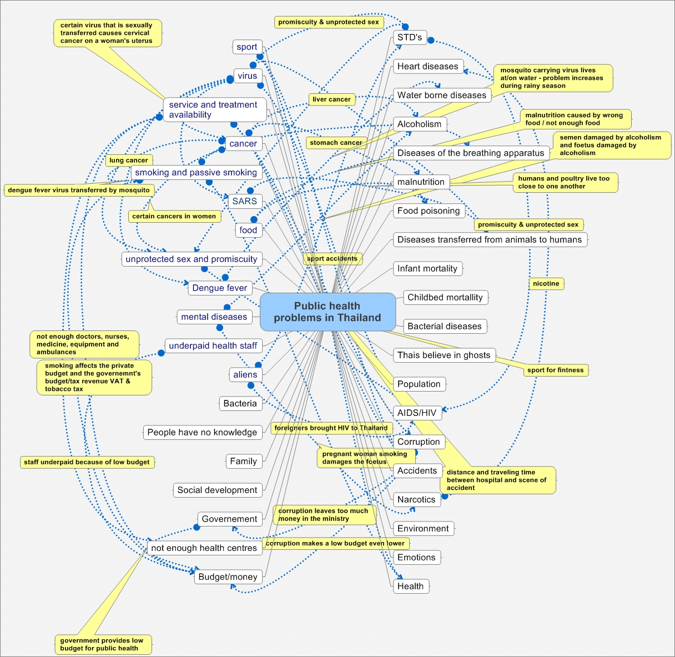
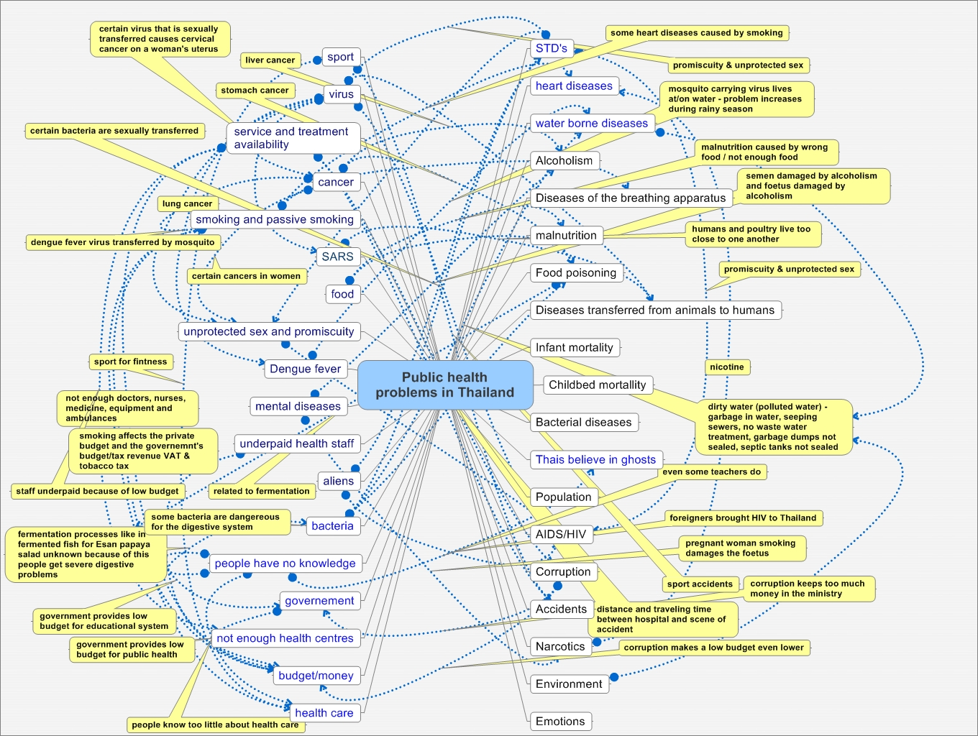
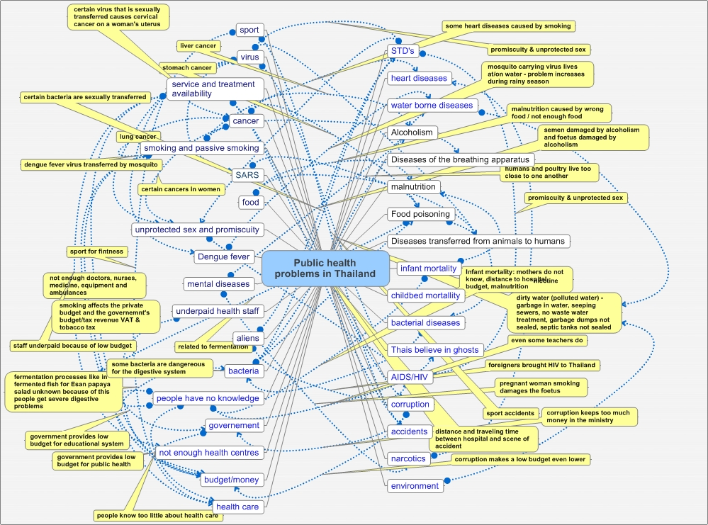
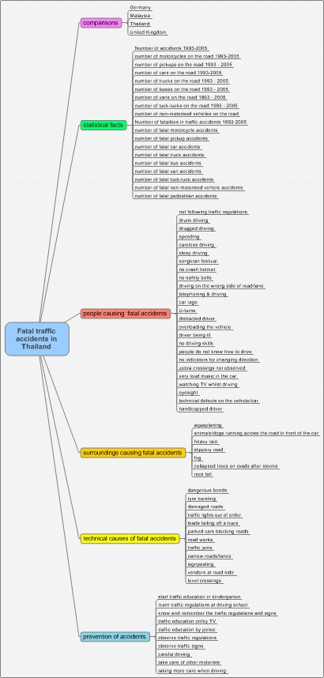

Two Individual papers from each map

1) A fourth year student working of fatal traffic accidents

Malaysia

Road traffic accidents are among the ten major causes of death in Malaysia. It is a shocking fact that road traffic accidents kill more people in other countries too, every year.
Traffic accidents kill more people than war and disease.
More than 20 million people are severely injured or killed on the world’s roads each year.
In Malaysia many people die from accidents.
Each year more than 5,000 people die. The number of fatal motorcycle accidents is very high. We can see this in this table.

Table : Road Accidents and people killed in Malaysia

 | 2001 | 2002 | 2003
Number of vehicles | 11,302,545 | 12,068,144 | 12,868,923
Number of accidents | 265,175 | 279,711 | 298,653
Total number of people killed | 5.210 | 5,267 | 5,573
Cyclists killed | 152 | 141 | 142
Motorcyclists killed | 3,465 | 3,520 | 3,764
Car drivers killed | 436 | 542 | 550
Bus passengers killed | 19 | 16 | 14
Truck drivers killed | 185 | 196 | 220
Pedestrians killed | 896 | 786 | 821

From the above table we see that the number of traffic accidents increased in the period 2001– 2003.
In 2001, the number of casualties was 5,210 and increased to 5,573 in 2003. The majority of these were motorcyclists, because people in Malaysia drive motorcycle more than other vehicles as the cost for a motorcycle are lower than for a car . Therefore the number of motorcycles on the road is higher.
Fifty percent of all fatal accidents are motorcycle accidents. Malaysia government is concerned about the number of fatal accidents on the road so it tries to pass a law to prevent accidents on the road.

From the death toll of accidents in Malaysia, we found that the number of deaths due to motorbike accidents is the highest. It also shows the various age groups in the table below

Table: Number people killed by motorcycle accidents
by age groups in Malaysia in 2001

Age | Deaths
0 - 10 | 8
11 - 15 | 120
16 – 20 | 937
21 – 25 | 671
26 - 30 | 441
31 – 35 | 320
36 – 40 | 250
41 – 45 | 180
46 – 50 | 175
51 - 55 | 132
56 – 60 | 96
61 – 65 | 98
66 -70 | 73
71 - 75 | 68
> 75 | 50
Total | 3,465

From the table, the highest death toll of motorbike accidents is 937 motorcyclists in the age group 16-20.
The cause may be the impetuous behavior of people in this age group. It is the same as in Thailand.
The next lower death tolls in the age group 21 - 25
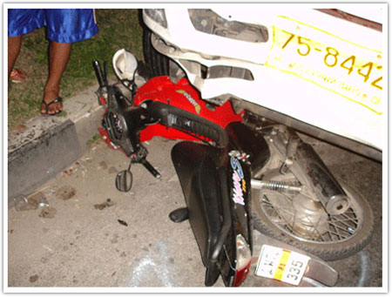
and 26 – 30. People in these age group work, so accidents may not come from their impetuousness. The most likely reason for the high death toll amongst people in these age groups may be that they generally used motorcycles for transportation, because motorbikes are very cheap in Malaysia. This may be the reason for the highest death toll in these two age groups.

The government of Malaysia loses a huge amount of money due to road accidents every year as you can see from the table below:

Table: Cost of road accidents in Malaysia

Year | Cost  ( $ million )
2001 | 1,754
2002 | 1,767
2003 | 1,884
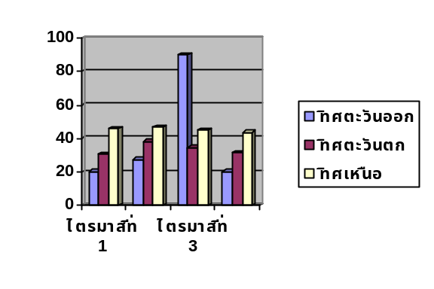

From the table, you see that government of Malaysia lost more than 1,700 million $, every and it increased every year.
Therefore the government realized the importance of the accident problem and looked for solutions of the accident problem in Malaysian.

2) A second year student working on public health problems in Thailand

Underpaid health staff
Cause

- Corruption because public money is kept in ministries so there is not enough money for development public health system.

- Low economy makes public health system receive low budget for health staff salary.

- Administration of hospitals because there is a difference between big and small sized hospitals. Small sized hospitals pay small salaries and health staff moves go cities for better salaries so there are not enough health staff in small sized hospitals.

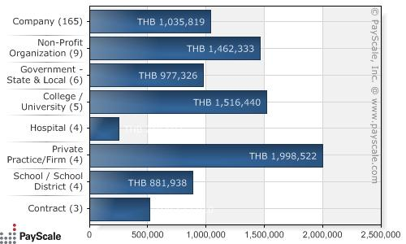

This is a graph that compares budgets between hospitals and other institutions showing that hospitals receive low budgets
The way to solve the problem of underpaid health staff

- Resist corruption, if there is no corruption health staff will get better salaries

- The government must administrate the economy well for the public health system to serve all people throughout the country.

Summarizing

Underpaid health staff is a public health problem in Thailand because budget or salary is the one factor in the work of health staff. If there are a low budget and low salaries health staff will move to cities where salaries are better, so there is not enough health staff in small sized hospitals.

Critical & Creative thinking Vol 16 No. 2, 2008, p 67
Critical & Creative thinking Vol 16 No. 2, 2008, p 67
Critical & Creative thinking Vol 16 No. 2, 2008, p 67

